Frequently Asked Questions (FAQs)

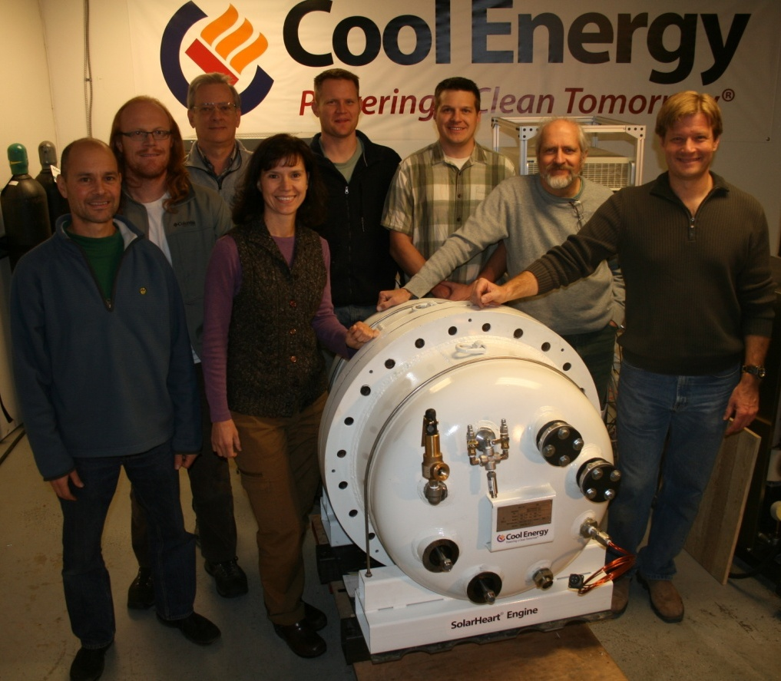

Company and SOLUTION

- What is the Cool Energy solution?
Cool Energy has developed a thermal-to-electrical power generation system for the conversion of wasted heat from engines and industrial processes into clean electricity. This system is built around an innovative advanced-materials Stirling engine which converts low-temperature (100-300C) heat to electricity. For waste heat applications we have developed the ThermoHeart Engine, and for Solar Thermal applications we have developed the SolarHeart Engine.

- What type of business is Cool Energy?
Cool Energy is a privately held corporation, based in Boulder, Colorado. Cool Energy is a certified B-Corporation committed to sustainability and social responsibility.

- How is Cool Energy funded?
To date, Cool Energy has been backed primarily by angel and venture capital investment and has been awarded several SBIR grants from the National Science Foundation, the Environmental Protection Agency, the Department of Energy subcontract, and a Colorado Governor’s Energy Office grant as well. Cool Energy is currently raising its Series B round of capital for the purposes of beginning volume manufacturing.
- How can I obtain a ThermoHeart Engine ?
Cool Energy is currently delivering pilot-stage 3kW and 20kW engines to qualified evaluation customers. Once the pilot testing phase is complete, Cool Energy will be selling the systems through certified dealers. These dealers will be trained in the operation, installation and maintenance of the system.

- When will the ThermoHeart Engines be commercially available?
With continued success and demand for our prototype engines, Cool Energy is actively pursuing collaborative partnership with engine manufacturers to go to market thru licensing agreements. The goal is to solidify manufacturing partners by mid 2015. The 20kW ThermoHeart engine will be the first model commercially available.

The engine size currently being tested is a 3kWe engine. A 20kW engine is in preliminary production, and even larger engines are planned for the future. The 20KW engines will be a perfect fit in light or heavy industrial applications such as coffee roasting, cement plants, glass plants, metal manufacturers, kilns, and so on.
- What will be the cost of the ThermoHeart Engine?
We estimate the market cost of the 3kW engine to be $8,000 - $12,000 USD in production quantities of 1,000 per year, and the 20kW to be $55,000 - $60,000 USD

- How many prototype SolarHeart Engines have you sold?
Cool Energy has sold three 4th generation 3kW engines that have a proven >20% thermal to electric conversion efficiency. One of the future 20kW engines has been sold and plans to be commissioned in the Winter of 2015.

- How do I know if the ThermoHeart Engine will work for my application?
The ThermoHeart Engine can be used with any heat source in the engine’s optimal input temperature range of 100-300°C, and heat flow range of 40-150 liters/min. The following are examples of possible applications:
• Commercial and industrial processes
• Diesel Generators (remote and military uses)
• Biomass processing
• Geothermal
• Solar Thermal
• Ship engines

Technology

- What is the Cool Energy technology?
The system is based on the ThermoHeart Engine which is a Stirling Engine (Invented in the early 1800’s by Robert Stirling). The Stirling engine is a heat engine that operates by expansion and compression of air or other gas (called the working fluid), at different temperature levels such that there is a net conversion of heat energy to mechanical work. The Cool Energy ThermoHeart uses nitrogen as the working fluid, and is driven by relatively low temperatures (100°C-300°C). The mechanical work generated drives a generator (built inside the engine) that creates electrical power.
- 300°C is too hot for water. What is the heat transfer fluid in the SolarFlow System?
The SolarFlow System uses a mineral-oil based, food-safe and non-toxic heat transfer fluid which is rated to 340°C.

- Does the ThermoHeart Engine make noise?
The ThermoHeart Engine is extremely quiet and low in vibration because it operates at a low speed (approximately 600 rpm), has no internal combustion or explosions and is fully balanced. The metal housing adds acoustic and thermal insulation.

- Is the ThermoHeart reliable?
The ThermoHeart Engine is designed for a 70,000 hour maintenance-free life. There is no lubrication required as all bearings are sealed.

- How much heat and electricity can be generated?
The chart below shows the modeled power output for given input temperature and flow rates. Testing of the 4th-generation 3kW engines has, so far, matched these development models.

Hot Side Input Temp (°C) | Oil Flow Rate (liters/min) | Electrical Output Power (W-dc) | Thermal to Electrical Conversion Efficiency (%)
100° C | 40 | 579 | 6.4%
100° C | 75 | 639 | 7.0%
100° C | 110 | 658 | 7.2%
100° C | 150 | 667 | 7.3%
150° C | 40 | 1288 | 12.9%
150° C | 75 | 1345 | 13.4%
150° C | 110 | 1362 | 13.6%
150° C | 150 | 1370 | 13.7%
200° C | 40 | 1911 | 17.8%
200° C | 75 | 1965 | 18.3%
200° C | 110 | 1981 | 18.4%
200° C | 150 | 1989 | 18.4%
250° C | 40 | 2462 | 21.6%
250° C | 75 | 2512 | 22.0%
250° C | 110 | 2527 | 22.1%
250° C | 150 | 2534 | 22.1%
300° C | 40 | 2954 | 24.6%
300° C | 75 | 3000 | 24.9%
300° C | 110 | 3014 | 25.0%
300° C | 150 | 3020 | 25.0%

Media Contact: Neshama Abraham (303) 413-8066; neshama@abrahampaiss.com

